**Lab 3**

**Fourier series, Fourier transform and Bode Plots in MATLAB**

**EECS3451**

**Name: Chethana Wickramasinghe**

**Student Number: 214866511**

**Professor: Peter Lian**

**11th of March 2021**

**1. Introduction:**

Using MATLAB to answer questions provided. Questions leads to plot periodic signals with Fourier series representation, obtain and plot the output response signal with a periodic input signal and o learn and create plots for the frequency response of a system (i.e. Bode plot) in MATALB. This report is mainly answering the provided questions using MATLAB. Results will demonstrate the use of MATLAB properly in analysing signals and systems.

**2. Equipment:** MATLAB

**3. Results and discussion:**

# 1. Periodic signals with Fourier series representation

## Laboratory Exercise 1

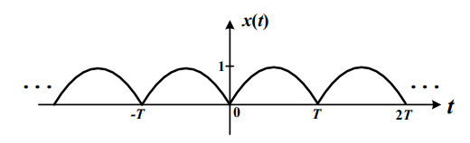Consider the following periodic signal x(t), which is a full-wave rectified sine-wave as shown in figure.

1. Determine the Fourier coefficients of x(t)

$x\left(t\right)=\left|\sin\left(ωot\right)\right| , ωo= π/T$

$a0=\frac{1}{To}\int_{0}^{T}{\sin\left(ωot\right)dt} =\frac{1}{To} \left(-\frac{\cos\left(ωoT\right)}{ωo}+\frac{1}{ωo}\right)= \frac{1}{T} \left(-\frac{\operatorname{Tcos}\left(π\right)}{π}+\frac{T}{π}\right)=\frac{1-\cos\left(π\right)}{π}$

$an= \frac{2}{To}\int_{0}^{T}{\sin\left(ωot\right)\cos\left(nωot\right)dt}$

$$=\frac{2}{T}\frac{\left(-\left(n-1\right)\cos\left(\left(n+1\right)Tωo\right)—\left(-n-1\right)\cos\left(\left(1-n\right)Tωo\right)-2\right)}{\left(2n^{2}-2\right)ωo}$$

$$=\frac{\left(-\left(n-1\right)\cos\left(\left(n+1\right)π\right)—\left(-n-1\right)\cos\left(\left(1-n\right)π\right)-2\right)}{(n^{2}-1)π}$$

$bn= \frac{2}{To}\int_{0}^{T}{\sin\left(ωot\right)\sin\left(nωot\right)dt}$

$$=\frac{2}{T}\frac{\left(-\left(n-1\right)\sin\left(\left(n+1\right)Tωo\right)—\left(n+1\right)\sin\left(\left(1-n\right)Tωo\right)\right)}{\left(2n^{2}-2\right)ωo}$$

$$=\frac{\left(-\left(n-1\right)\sin\left(\left(n+1\right)π\right)—\left(n+1\right)\sin\left(\left(1-n\right)π\right)\right)}{(n^{2}-1)π}$$

1. Plot x(t) in MATALB that considers the first 40 terms in the Fourier series if T = 2 seconds. Plot x(t) for -4 ≤ t ≤ 4. [Note: you should not simply enter term by term in MATLAB to complete the plot]

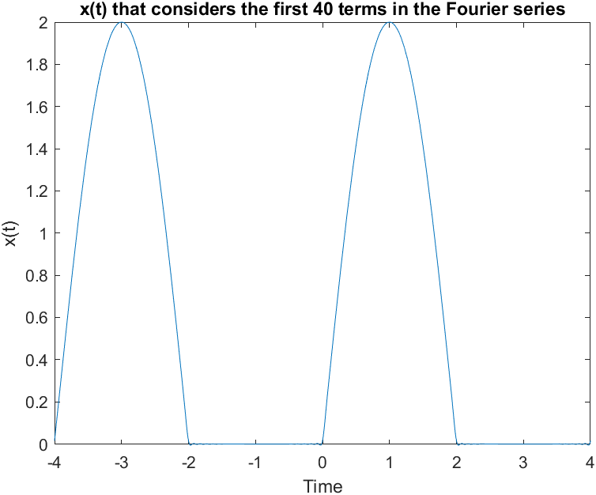 $x\left(t\right)=ao+ \sum_{n=1}^{∞}{[an\cos\left(\frac{2πnt}{3}\right)+bn\sin\left(\frac{2πnt}{3}\right) ]}$

1. Based on the Fourier coefficients, if T = 2 seconds, plot both the magnitude spectrum and phase spectrum of x(t) as a function of n for -10 ≤ n ≤ 10 in MATLAB. Use MATLAB built-in function stem()to plot all the points in both plots. Use subplot() to plot the magnitude spectrum in the upper plot and the phase spectrum in the lower plot. Label both plots.
2. x(t) is now an input signal for an LTIC system with impulse response h(t), and the Fourier

transform of h(t) in this system is: $H\left(ω\right)=\frac{10}{30.5+jω}$. Determine the output response

signal y(t). Plot both x(t) and the output signal y(t) on the same graph. Plot a few cycles.

$H\left(ω\right)=\frac{Y\left(ω\right)}{X\left(ω\right)}= \frac{10}{30.5+jω}$

$Y\left(ω\right)\left(30.5+jω\right)=10 X\left(ω\right)$

$jω Y\left(ω\right)+30.5 Y\left(ω\right)=10 X\left(ω\right)$

$\frac{dy\left(t\right)}{dt}+30.5 y\left(t\right)=10 x(t)$

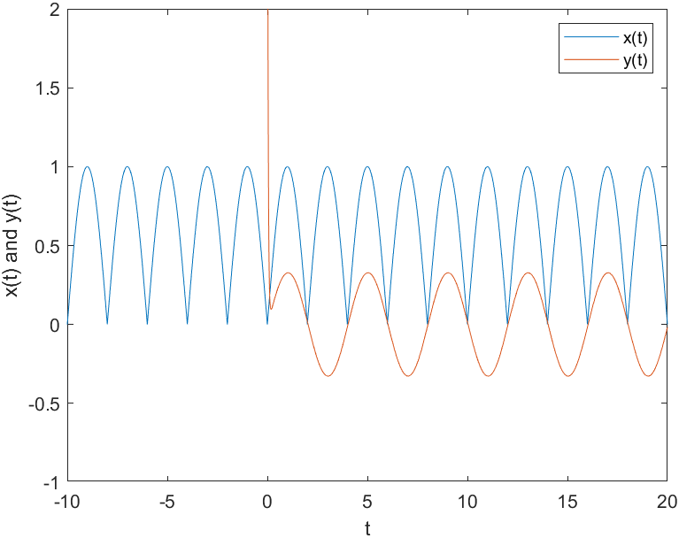

## Laboratory Exercise 2

1. 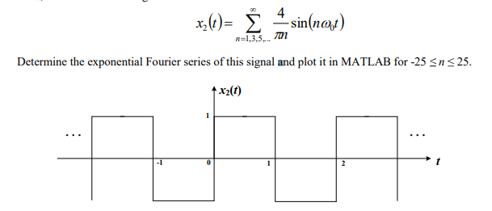Consider a symmetrical square wave signal x2(t) with an amplitude of 1 and a fundamental period of T0, the Fourier series is given as:

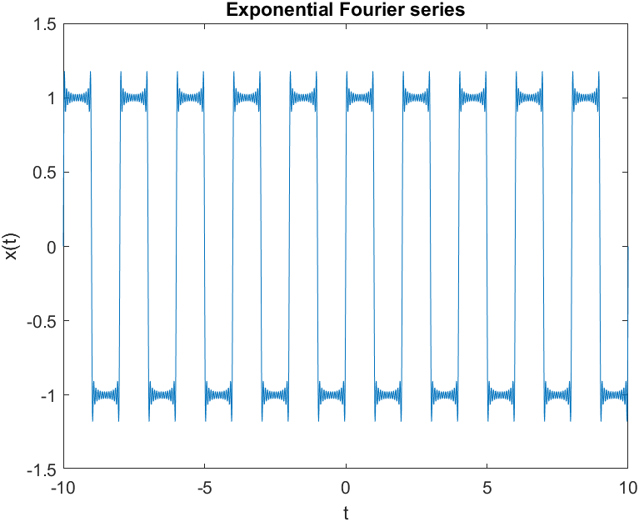11111111111111111111111111111111111111111111111

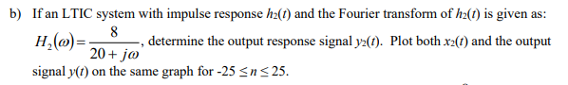

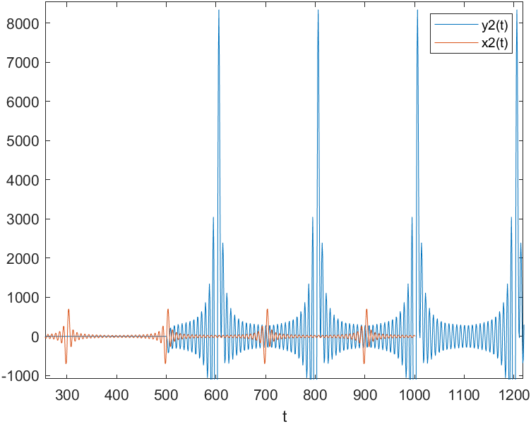

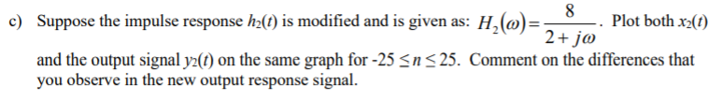

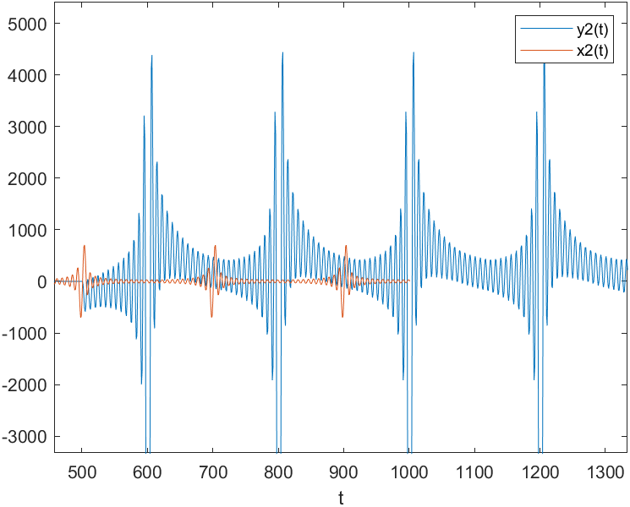

Extra

If $H\left(ω\right)=\frac{8}{0.5+jω}$

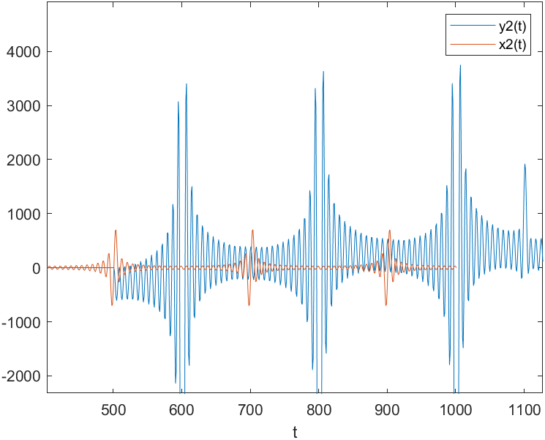

Observation

$H\left(ω\right)=\frac{8}{0.5+jω}$-> $H\left(ω\right)=\frac{8}{2+jω}$-> $H\left(ω\right)=\frac{8}{20+jω}$

Along to the right the output response graph y(t) gets more and more stretched along the y axis.

# 2. Creating Bode plots (i.e. gain and phase responses) in MATLAB

## Laboratory Exercise 3



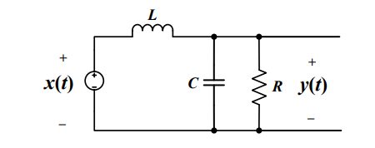

KCL at the red dot,

$\frac{1}{L}\int{y\left(t\right)-x\left(t\right)dt }+\frac{y\left(t\right)}{R}+\frac{Cdy(t)}{dt}=0$

Reduced to,

$\frac{y\left(t\right)}{L}-\frac{x\left(t\right)}{L}+\frac{dy\left(t\right)}{R dt}+C\frac{d^{2}y\left(t\right)}{dt}=0$

$\frac{y\left(t\right)}{L}+\frac{dy\left(t\right)}{R dt}+C\frac{d^{2}y\left(t\right)}{dt}=\frac{x\left(t\right)}{L}$

$y(t)+\frac{L dy\left(t\right)}{R dt}+CL\frac{d^{2}y\left(t\right)}{dt}=x(t)$

$\frac{y\left(t\right)}{CL}+\frac{ dy\left(t\right)}{RC dt}+\frac{d^{2}y\left(t\right)}{dt}=\frac{x\left(t\right)}{CL}$

R = 2, L = 1e-3 H , C= 10e-6 F

$\frac{d^{2}y\left(t\right)}{dt} +\frac{ dy\left(t\right)}{(10e-6 *2) dt}+\frac{y\left(t\right)}{(10e-6 * 1e-3)}=\frac{x\left(t\right)}{(10e-6 * 1e-3)}$

$\frac{d^{2}y\left(t\right)}{dt} +\frac{ dy\left(t\right)}{(2e-5) dt}+\frac{y\left(t\right)}{(10e-9)}=\frac{x\left(t\right)}{(10e-9)}$

${[\left(jω\right)}^{2} +5e4jω+{10}^{8}]Y\left(ω\right)={10}^{8}X(ω)$

$H\left(ω\right)=\frac{Y\left(ω\right)}{X\left(ω\right)}=\frac{{10}^{8}}{{[\left(jω\right)}^{2} +5e4jω+{10}^{8}]}$

(s = jω)

$H\left(s\right)=\frac{{10}^{8}}{s^{2} +5e4s+{10}^{8}}$

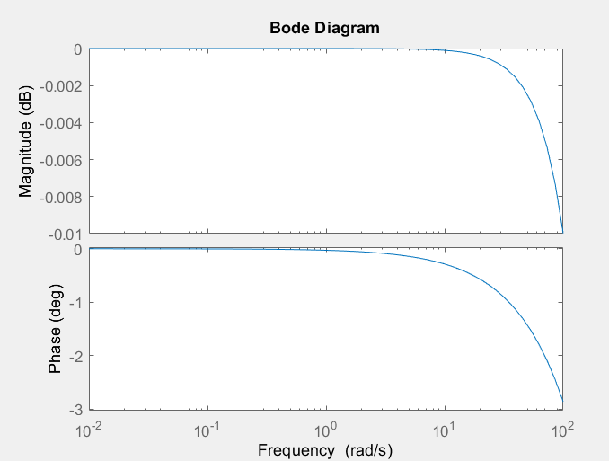

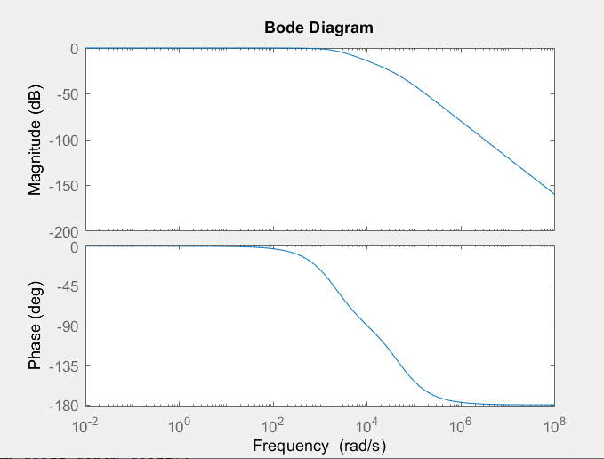

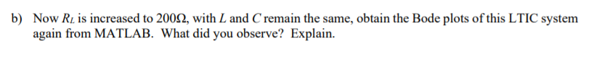

R = 200, L = 1e-3 H , C= 10e-6 F

$\frac{d^{2}y\left(t\right)}{dt} +\frac{ dy\left(t\right)}{(10e-6 *200) dt}+\frac{y\left(t\right)}{(10e-6 * 1e-3)}=\frac{x\left(t\right)}{(10e-6 * 1e-3)}$

$\frac{d^{2}y\left(t\right)}{dt} +\frac{ dy\left(t\right)}{(2e-3) dt}+\frac{y\left(t\right)}{(10e-9)}=\frac{x\left(t\right)}{(10e-9)}$

${[\left(jω\right)}^{2} +500jω+{10}^{8}]Y\left(ω\right)={10}^{8}X(ω)$

$H\left(ω\right)=\frac{Y\left(ω\right)}{X\left(ω\right)}=\frac{{10}^{8}}{{[\left(jω\right)}^{2} +500jω+{10}^{8}]}$

(s = jω)

$H\left(s\right)=\frac{{10}^{8}}{s^{2} +500s+{10}^{8}}$

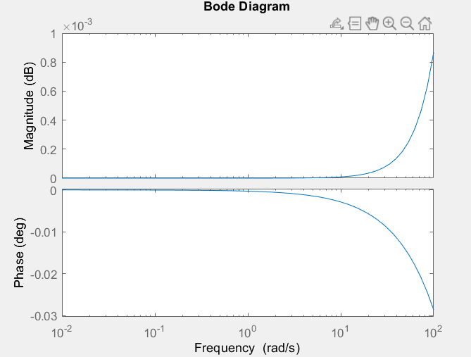

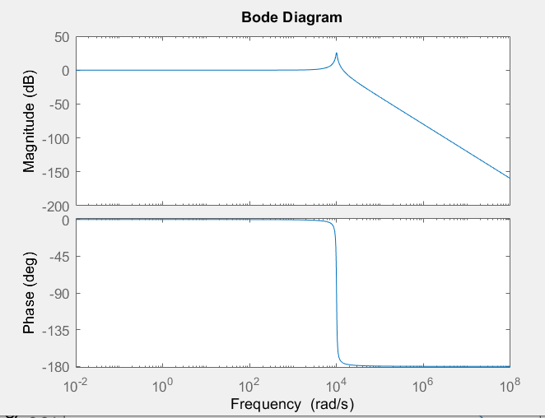

**Observations:**

When R value increased to 200, the magnitude flipped and now has positive values and stretched along x axis, while the phase remain in negative values but is compressed along the x-axis.

This is because, R= 2 has more phase margin and more stable than when R increase to 200.

**Extra**

R = 0.2, L = 1e-3 H , C= 10e-6 F

$\frac{d^{2}y\left(t\right)}{dt} +\frac{ dy\left(t\right)}{(10e-6 *0.2) dt}+\frac{y\left(t\right)}{(10e-6 * 1e-3)}=\frac{x\left(t\right)}{(10e-6 * 1e-3)}$

$\frac{d^{2}y\left(t\right)}{dt} +\frac{ dy\left(t\right)}{(2e-6) dt}+\frac{y\left(t\right)}{(10e-9)}=\frac{x\left(t\right)}{(10e-9)}$

${[\left(jω\right)}^{2} +5e5jω+{10}^{8}]Y\left(ω\right)={10}^{8}X(ω)$

$H\left(ω\right)=\frac{Y\left(ω\right)}{X\left(ω\right)}=\frac{{10}^{8}}{{[\left(jω\right)}^{2} +5e5jω+{10}^{8}]}$

(s = jω)

$H\left(s\right)=\frac{{10}^{8}}{s^{2} +5e5s+{10}^{8}}$

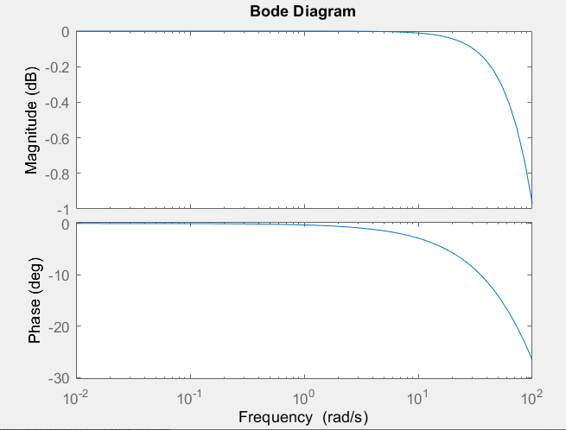

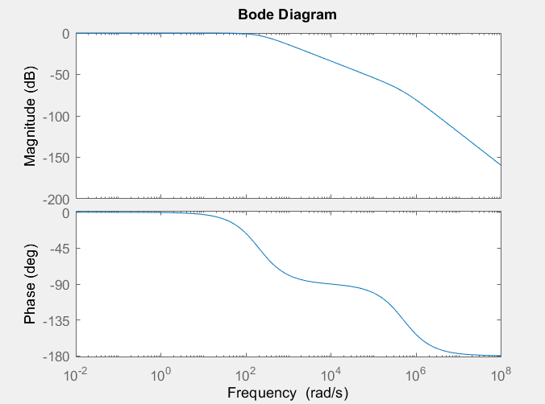

**4. Conclusion: state what you learn from this lab, lab objectives you achieved, and any difficulties you met.**

~~Learned how to plot CT signals, DT signals, rectangular pulse functions, Unit step functions, sign functions, sinusoidal functions, exponential functions in MATLAB using pre defined functions such as real(), imag(), etc.~~

~~All the questions were answered using MATLAB and was able to get a better understanding of signals and systems by observing the generated plots.~~

~~Had a hard time to find how to plot a rectangular pulse function. In addition, had to review formulas related to circuits and waveforms.~~